CSC 134 Spring 2015
Homework 3
Total: 100 points

This homework allows students to practice the development of a database using MySQL.

Section 1
Using SQL, create tables according to the given schema shown in Figure 1. You must use exactly the same names for tables and attributes as the ones in Figure 1. Define a reasonable type for each attribute. Make sure the types you defined have no conflict with the queries in Section 3. The ER diagram is shown in Figure 2.
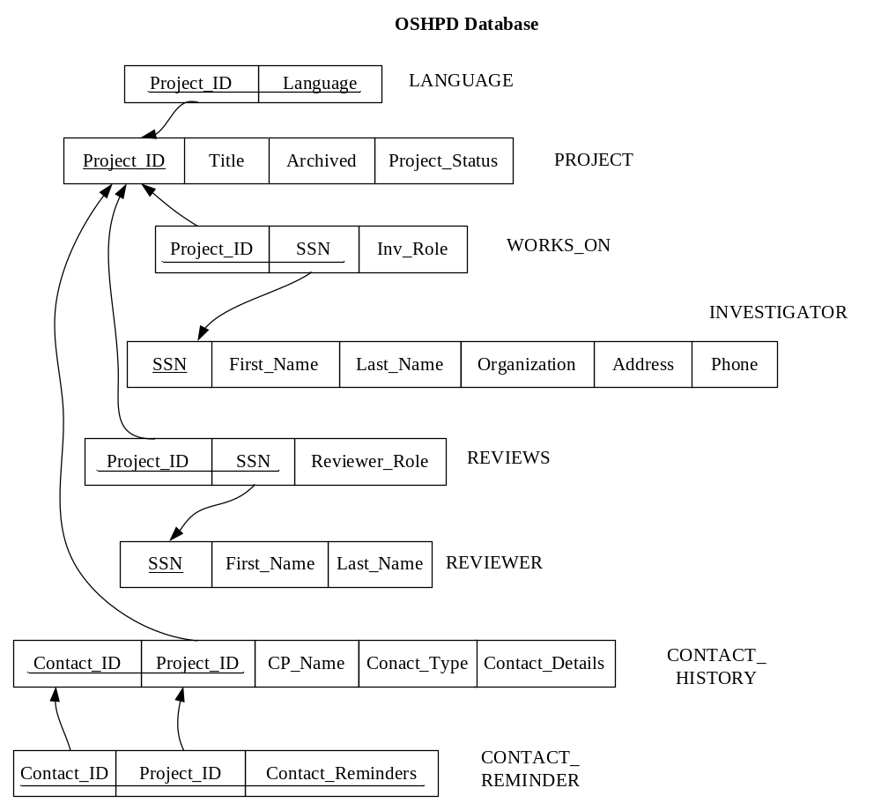

Figure 1 Schema

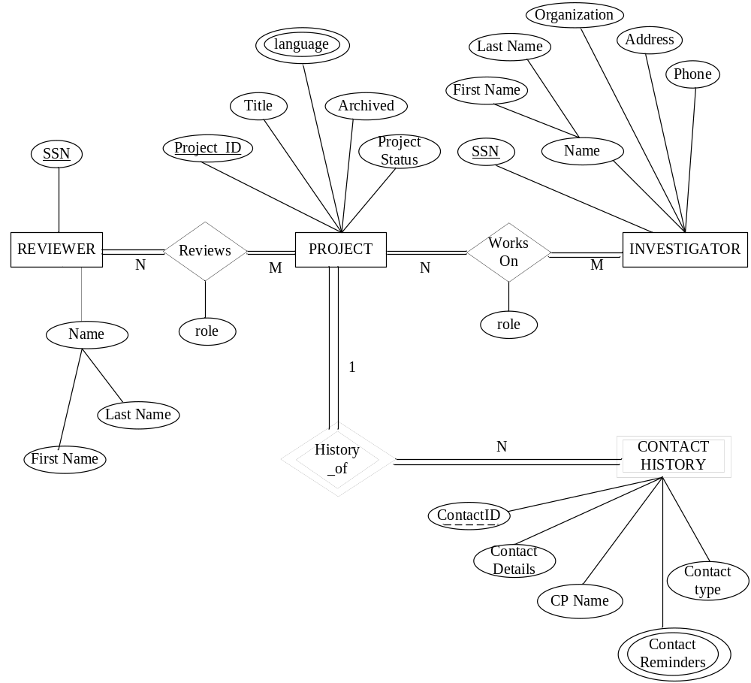

Figure 2 ER Diagram

Section 2
Populate the database. Please check sections 3 for details.

Section 3
Use SQL to specify the following queries. When you populate the database, insert data such that at least one row will be display as the result of running each query.
- Retrieve information about the projects (title, status and whether archived or not) that have an ‘Optional’ reviewer.
- Retrieve the information about the investigators (first name, last name and organization) who have done more than one project.
- Retrieve the information of reviewers (first name and last name), investigators (first name and last name) for the project “Air Quality Research Project”.
- Get the contact information (contact number, contact person name, contact type and contact remainders) for the projects which have a contact history. Also get the Project_IDs for those projects.
- Get the project information (project id, title, status and whether archived or not) which has a ‘Co_PI’.
- Retrieve all the projects (project id, title) in which “John Smith” serves as a principle investigator.
- Retrieve the reviewers who reviewed more than 2 projects. Please list reviewer’s SSN and number of projects reviewed by the reviewer.

Section 4
Specify the statements to drop all the tables. Pay attention to the order of the drop statements in order to drop everything successfully.

Submission

Submit the following files to SacCT.
- Create table statements (file name must be: 1_create_table.sql)
- Insert statements to populate database (file name must be : 2_populate_db.sql)
- Queries (file name must be: 3_query.sql)
- Statements to drop all tables (file name must be: 4_drop_all.sql)
- An output file showing query results (file name must be: 5_output.pdf, or or 5_output.txt). In this file, for each query, you must:
  - Include the number and query description (e.g Query 1: Retrieve information …)
  - Your SQL query (e.g. select… from…)
  - The result of running this query.

